Class: 17C1 – FIFTEEN - MINUTE TEST
Name: ___________________ Date: November _________, 2018

I. Choose the best answer:
1) Shock absorber is a component of _________ .
A. gas central heating B. washing machine
D. Vacuum cleaner C. Fridge
2) Adjusting the sound of a TV is an example for _________ .
A. The control may change the size of the input.
B. The control may change the shape of the input.
C. The control may change the size of the output.
D. The control may change the shape of the output.
3) Opening the window may set off a burglar alarm is an example for _________ .
A. The control involves changing one kind of input into a different kind of output.
B. The control involves changing one kind of output into the same kind of input.
C. The control involves changing one kind of input into the same kind of output.
D. All are not correct.
4) The control system of a modern washing machine has to take into account several different factors such as door position, water level, water temperature, wash and spin times and _________ .
A. large of drum. B. size of drum. C. shape of drum. D. speed of drum
5) Most washing machines use 53 rpm for _________ .
A. spinning B. distributing the load before spinning.
C. washing D. mixing
6. The machine will not start any _________ unless the door is fully closed and locked.
A. heating B. service
D. loop C. program
7. The _________ water level is checked by the water level sensor.
A. heating B. compressing
D. depending C. rising

8. If t he water temperature is too low, the control unit will switch on the _________ .
A. solenoid B. heater
D. cleaner C. fridge
9. The electronic clock built into the control unit keeps the memory of the control unit informed so that each stage of each program is _________ correctly.
A. timed B. measured
D. operated C. reached
II. Use the suitable words in the box to fill in the following number:

Shock absorber – water in – Solenoid valves – Pressure sensor – Temperature sensor – Heater – Motor – Fan – Pump – Door lock and sensor – Control unit – Drum – Water out

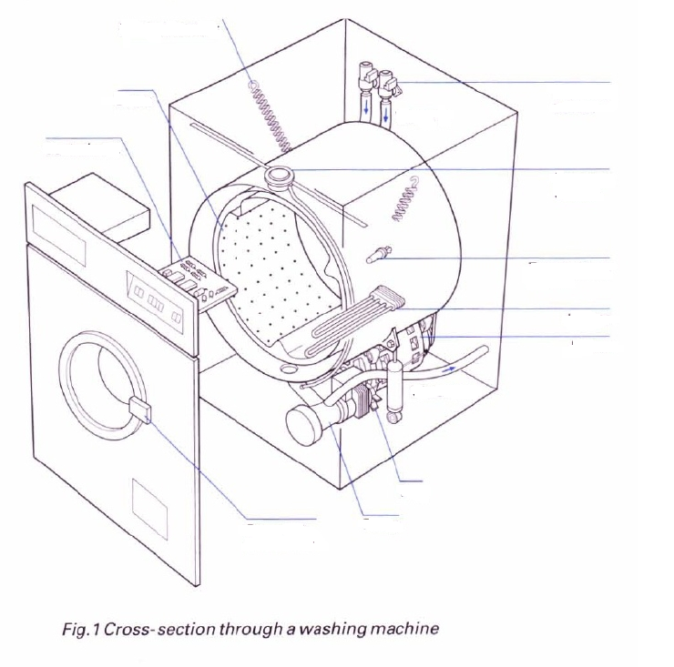
1
2
3
4
5
6
7
8
9
10
11
1. _________
2. _________
3. _________
4. _________
5. _________
6. _________
7. _________
8. _________
9. _________
10. _________
11. _________

